# VARDHAMAN COLLEGE OF ENGINEERING, HYDERABAD

**Autonomous institute affiliated to JNTUH**

##### DEPARTMENT OF MECHANICAL ENGINEERING

##### Academic Year: 2024 –2025

##### B. Tech IV Year I Semester – ME

##### **PRODUCTION PLANNING AND CONTROL**

**UNIT-IV**

Aggregate production planning is concerned with the determination of production, inventory, and work force levels to meet fluctuating demand requirements over a planning horizon that ranges from six months to one year.

The aggregate production approach is predicated on the existence of an *aggregate unit of production*, such as the average" item, or in terms of weight, volume, production time, or dollar value. Plans are then based on aggregate demand for one or more aggregate items. Once the aggregate production plan is generated, constraints are imposed on the detailed production scheduling process which decides the specific quantities to be produced of each individual item.

## Importance of Aggregate Planning

* Achieving financial goals by reducing overall variable cost and improving the bottom line
* Maximum utilization of the available production facility
* Provide customer delight by matching demand and reducing wait time for customers
* Reduce investment in inventory stocking
* Able to meet scheduling goals there by creating a happy and satisfied work force

## Inputs and Outputs to Aggregate Production Planning Aggregate Production Planning Demand Forecasts Company Policies Financ...Inputs and outputs to the Aggregate Planning

## Inputs to the Aggregate Planning

* Capacity constraints
* Strategy objectives
* Company policies
* Demand forecasts
* Financial constraints

### Outputs to the Aggregate Planning

* Workforce level
* Production per month
* Inventory level
* Backorders
* Subcontracts

***Plan 1***: *Varying the Workforce Size*. Demand can be met exactly by varying the workforce size. The plan involves hiring and firing as necessary. The production rate will equal the demand.

***Plan 2***: *Changing Inventory Levels*. Suppose that a firm wants to avoid frequent hiring and layoffs. It might choose a production level equal to its average demand and meet the variations in demand by holding inventory

***Plan 3:*** *Subcontracting*. A firm might prefer to produce an amount equal to its lowest requirements and meet the rest of the demand by subcontracting.

## Aggregate Planning Strategies

1. Level Strategy
2. Chase Strategy
3. Mixed Strategy

**Level Strategy:** The production-smoothing plan

As the name suggests, level strategy looks to maintain a steady production rate and workforce level. In this strategy, organization requires a robust forecast demand as to increase or decrease production in anticipation of lower or higher customer demand. Advantage of level strategy is steady workforce. Disadvantage of level strategy is high inventory and increase back logs.

* + Produce same amount every day
  + Keep work force level constant
  + Sets capacity to accommodate average demand
  + Often results in lowest production costs
  + Often used for make-to-stock products like appliances
  + Use inventory or idle time as buffer
  + Disadvantage- builds inventory and/or uses back orders

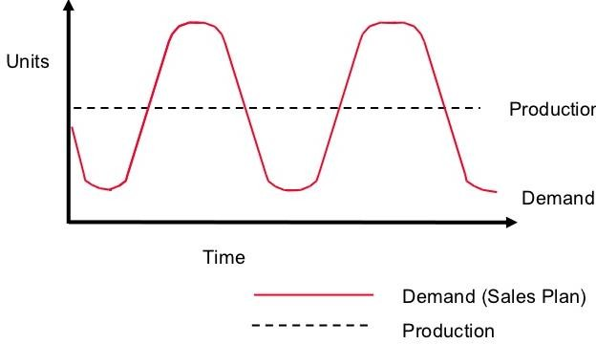

## Chase Strategy:

As the name suggests, chase strategy looks to dynamically match demand with production. Advantage of chase strategy is lower inventory levels and back logs. Disadvantage is lower productivity, quality and depressed work force.

* Match output rates to demand forecast for each period
* Produces exactly what is needed each period
* Vary workforce levels or vary production rate
* Sets equipment capacity to satisfy period demands
* Favoured by many service organizations
* Disadvantage- constantly changing short term capacity

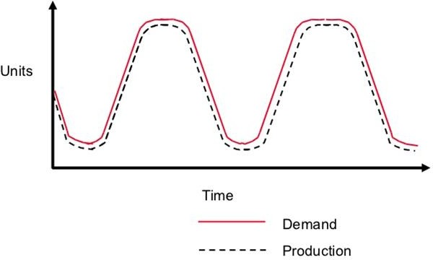

### Mixed Strategy :

As the name suggests, hybrid strategy looks to balance between level strategy and chase strategy.

As a compromise, a firm might combine the pure strategies, thus designing a mixed strategy. This mixed strategy varies production capacity slightly up or down as aggregated demand varies. Drastic changes in production capacity are curtailed, and frequent hiring and lay off situations are avoided.

Mixed strategies for meeting the demand

* + Overtime/ under time production
  + Hiring/firing the work force
  + Inventory/backordering
  + Subcontracting out/in
  + Part time/Full time

## LINE BALANCING

This is an analysis process which tries to equally divide work to be carried out in a production process among workstations.

## Objectives of Line balancing

* To minimize the cycle time.
* To maximize the workload smoothness.
* Manage the workloads among assemblers.
* To recognize the location of bottleneck.
* To decide number of workstation.
* To minimize the number of workstations.
* To decrease production cost.
* Assigning task to each work station in such a way that there is little idle time.

## Line Balancing Methods

These methods are heuristic approaches, meaning that they are based on logic and common sense rather than on mathematical proof.

None of the methods guarantees an optimal solution, but they are likely to result in good solutions which approach the true optimum.

The manual methods to be presented are :

1. Largest-candidate rule
2. Kilbridge and Wester’s method
3. Ranked positional weights method

## Line balancing general procedure:

* 1. Determination of tasks that must be performed to complete one unit of a product.
  2. Determining the order or sequence of performing the whole set of tasks.
  3. Drawing precedence diagram. In this flowchart circles represents task and joining arrows represents precedence.
  4. Estimation of task time.
  5. Calculation of cycle time. (In Largest-candidate rule consider highest elemental time as cycle time)
  6. Determination of minimum number of workstation required.
  7. Assign tasks to workstations for balancing production line.
  8. Allocation of elements to the workstations by their ranks
  9. Determine the balance efficiency

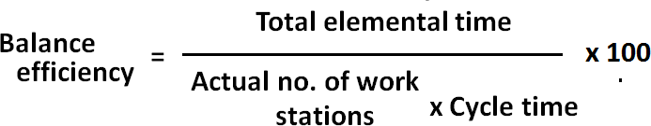

* 1. Determine the balance delay

## Balance delay = 100 - Balance efficiency

**Example :** Design line balance for the following data for the cycle time of 10 Min.

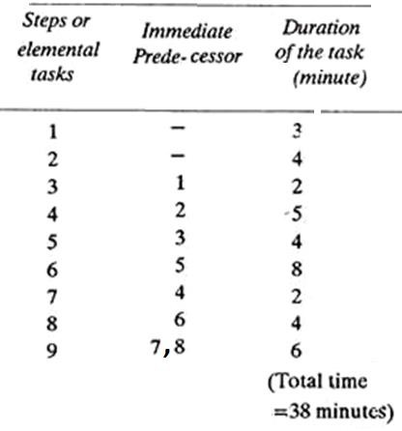

* Sketch the precedence diagram and mark the task duration

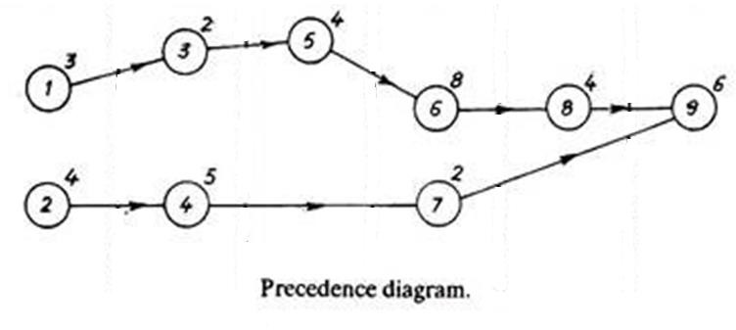

* The total elemental time = 38 minutes
* The minimum number of stations required are

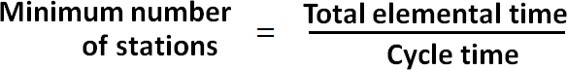

= 38/10 =3.8 say 4.

* Allocating elements to work stations

|  |  |  |  |
| --- | --- | --- | --- |
| **Work station No.** | **Work elements** | **Work Station time (Min)** | **Idle Time (Min)** |
| I | 1, 2, 3 | 3+4+2 =9 | 1 |
| II | 4, 5 | 5+4 =9 | 1 |
| III | 6, 7 | 8+2 = 10 | 0 |
| IV | 8, 9 | 4+5 = 9 | 1 |

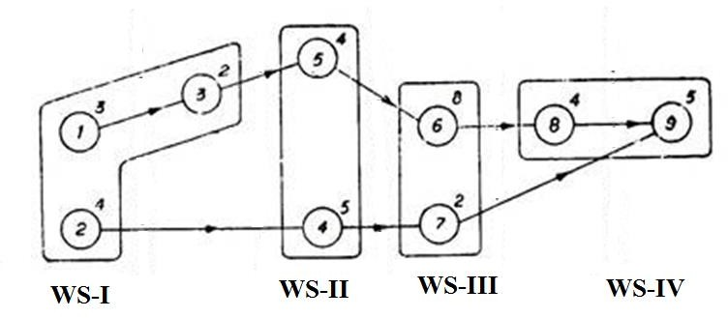

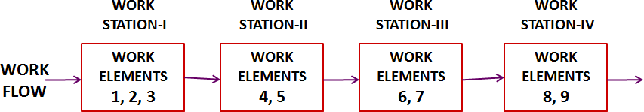



= [38 /( 4 x 10) ] x 100

## = 95 %

**Balance delay = 100 - Balance efficiency**

## = 100 – 95 = 5 %

**Line balancing by Rank Positional Weights method**

1. Determination of tasks that must be performed to complete one unit of a product.
2. Determining the order or sequence of performing the whole set of tasks.
3. Drawing precedence diagram. In this flowchart circles represents task and joining arrows represents precedence.
4. Estimation of total elemental time.
5. Calculation of cycle time.



1. Determination of minimum number of workstation required.
2. Determine the positional weights of all elements.
3. Specify the positional weights of all elements in precedence diagram.
4. 9. Assign the ranks to positional weights of all elements.
5. 10. Allocation of elements to the workstations by their ranks
6. Determine the balance efficiency



1. Determine the balance delay

## Balance delay = 100 - Balance efficiency

**Example 2 :** Design line balance by rank positional weights method for the following data for the cycle time of 10 Min.

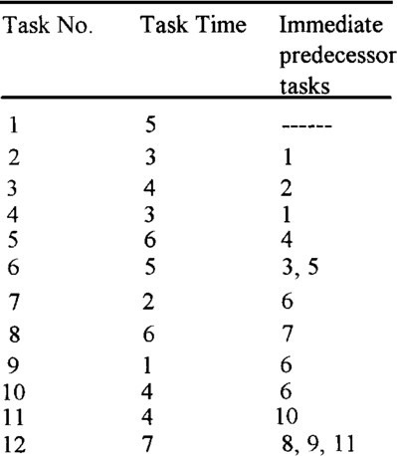

* Sketch the precedence diagram and mark the task duration

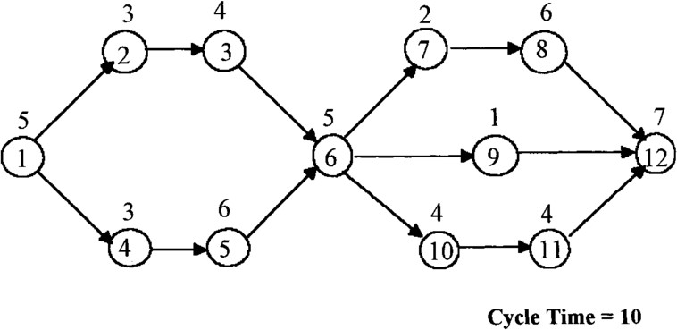

* The total elemental time = 50 minutes
* Cycle time = 10 Min.
* The minimum number of stations required are



= 50/10

= 5 min.

* Determine the positional weights of all elements and assign the rank

|  |  |  |  |  |
| --- | --- | --- | --- | --- |
| **Element** | **Duration** | **Precedence** | **Positional weight** | **Rank** |
| 1 | 5 | -- | 50 | 1 |
| 2 | 3 | 1 | 36 | 3 |
| 3 | 4 | 2 | 33 | 5 |
| 4 | 3 | 1 | 38 | 2 |
| 5 | 6 | 4 | 35 | 4 |
| 6 | 5 | 3, 5 | 29 | 6 |
| 7 | 2 | 6 | 15 | 7 |
| 8 | 6 | 7 | 13 | 9 |
| 9 | 1 | 6 | 8 | 11 |
| 10 | 4 | 6 | 15 | 8 |
| 11 | 4 | 10 | 11 | 10 |
| 12 | 7 | 8, 9, 11 | 7 | 12 |

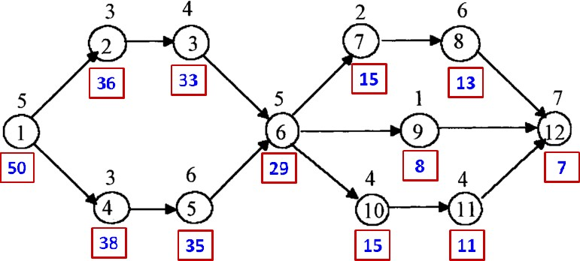

* Allocation of elements to the workstations

|  |  |  |  |
| --- | --- | --- | --- |
| **Work**  **station No.** | **Work element** | **Work Station**  **time (Min)** | **Idle**  **Time (Min)** |
| I | 1, 4 | 5+3 = 8 | 2 |
| II | 2, 5 | 3+6 =9 | 1 |
| III | 3, 6 | 4+5 = 9 | 1 |
| IV | 7, 10, 11 | 2+4+4 = 10 | 0 |
| V | 8, 9 | 6+1 = 7 | 3 |
| VI | 12 | 7 | 3 |

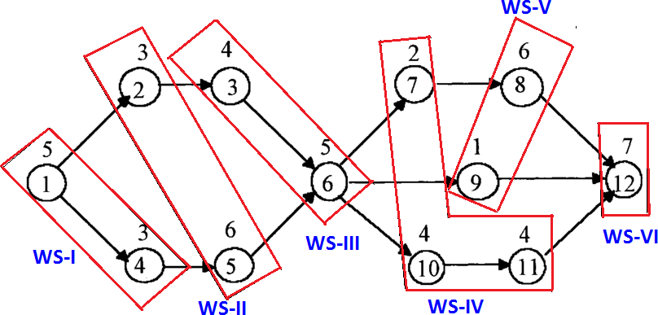

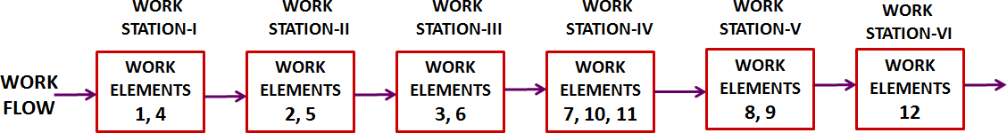



= [50 /( 6 x 10) ] x 100

## = 83.33 %

**Balance delay = 100 - Balance efficiency**

## = 100 – 83.33

**= 16.67 %**

**SCHEDULING**

# Commonly Used Priorities Rules

1. First come, first served (FCFS)
2. Last come, first served (LCFS)
3. Earliest due date (EDD)
4. Shortest processing time (SPT)
5. Longest processing time (LPT)
6. Critical ratio (CR):

(Time until due date)/(processing time)

1. Slack per remaining Operations (S/RO)

Slack /(number of remaining operations)

1. **First come, first served (FCFS)**

Jobs are processed in the order in which they arrive at a machine or work center.

1. **Shortest Processing Time (SPT)**

Shortest Processing Time. Jobs with the shortest processing time are scheduled first. Jobs are sequenced in increasing order of their processing time.

Shortest processing time is optimal for minimizing: Average and total flow time

Average waiting time Average and total lateness

**The steps for using this rule are :**

* 1. Firstly, the user will input the number of jobs, the job names, the processing time and the due date of each job or use the data values given at the starting point.
  2. The second step is sorting out the shortest processing time among the jobs.
  3. Thirdly, calculate the flow time of each job by using the processing time. The flow time is the accumulation of processing time each job by each job.

1. **Earliest Due Date (EDD)**

* Jobs are sequenced in increasing order of their due dates;
* The job with earliest due date is first, the one with the next earliest due date is second, and so on;
* A priority sequencing rule that specifies that the job with the earliest due date is the next job to be processed

**The steps for using this rule are :**

* 1. Firstly, the user will input the number of jobs, the job names, the processing time and the due date of each job or use the data values given at the starting point.
  2. The second step is sorting out the earliest due date among the jobs.
  3. Thirdly, calculate the flow time of each job by using the processing time. The flow time is the accumulation of processing time each job by each job.
  4. **Critical Ratio (CR)**
     + Is an index number computed by dividing the time remaining until due date by the work time remaining.
     + The critical ratio gives priority to jobs that must be done to keep shipping on schedule.
     + The critical ratio is measure of urgency of any order compared to the other orders for the same facility.
     + The ratio is based on when the completed order is required and how much time is required to complete.

**The step for using this rule are:**

1. At the starting program, user input the numbers of job, the jobs name, the works day remaining and the due date of each job and as well the today's date.
2. The today's date and the number of job are just inputted once time. Then, the others are followed the value of the number of jobs inputted. After that, compute the critical ratio by using the formula.
3. The formula for Critical Ratio is:

***CR = time remaining / works day remaining***

1. After calculating the CR for each job, give the priority order by using the value of the c**a**lculated critical ratio. The priority order is performed from smaller to larger.

* **The critical ratio help in most production scheduling system as below:**
* Determine the status of specific job.
* Establish relative priority among jobs on a common basis.
* Relate both stock and make-to-order jobs on a common basis.
* Adjust priorities (and revise schedules) automatically for changes in both demand and job progress.
* Dynamically track job progress and location.

# Measuring Performance

* **Job flow time:**
  + Time a job is completed minus the time the job was first available for processing; **avg. flow time measures responsiveness**
* **Average # jobs in system:**
  + Measures amount of work-in-progress; **avg. # measures responsiveness and work-in- process inventory**
* **Makespan:**
  + The time it takes to finish a batch of jobs; **measure of efficiency**
* **Job lateness:**
  + Whether the job is completed ahead of, on, or behind schedule;
* **Job tardiness**:
  + How long after the due date a job was completed, **measures due date performance**
  1. Processing Time (including setup times) and due dates for six jobs waiting to be processed at a work center are given in the following table. Determine the sequence of jobs, the average flow time, average tardiness, and number of jobs at the work center, for each of these rules:
     + FCFS, SPT, EDD,

|  |  |  |  |
| --- | --- | --- | --- |
|  |  |  |  |
| **Job number** | **Processing Time** | **Due Date** |
| A B C D E  F | 2  8  4  10  5  12 | 7  16  4  17  15  18 |
|  | | | |

**Solution:**

# First come, first served (FCFS)

|  |  |  |  |  |
| --- | --- | --- | --- | --- |
| **Job**  **Sequence** | **Processing**  **Time** | **Flow**  **Time** | **Due**  **Date** | **Tardiness** |
| A | 2 | 2 | 7 | 0 |
| B | 8 | 10 | 16 | 0 |
| C | 4 | 14 | 4 | 10 |
| D | 10 | 24 | 17 | 7 |
| E | 5 | 29 | 15 | 14 |
| F | 12 | 41 | 18 | 23 |
| Totals | 41 | 120 |  | 54 |

Average completion time

= Total completion Time/ No.of jobs

=120/6

= 20 days

Average number of jobs in the system

= Total completion Time/ Total Processing Time

=120/41

= 2.93 jobs

Average tardiness = Total tardiness / No.of jobs

= 54/6

= 9 days

Utilization

= (Total processing time/ Total completion time) x100 (41/120) x 100 = 34.17%

# Shortest processing time (SPT)

**Optimal sequence:**

|  |  |  |  |  |  |
| --- | --- | --- | --- | --- | --- |
| **A** | **C** | **E** | **B** | **D** | **F** |

|  |  |  |  |  |
| --- | --- | --- | --- | --- |
| **Job**  **Sequence** | **Processing**  **Time** | **Flow Time** | **Due Date** | **Tardiness** |
| A | 2 | 2 | 7 | 0 |
| C | 4 | 6 | 4 | 2 |
| E | 5 | 11 | 15 | 0 |
| B | 8 | 19 | 16 | 3 |
| D | 10 | 29 | 17 | 12 |
| F | 12 | 41 | 18 | 23 |
| Totals | 41 | 108 |  | 40 |

Average completion time

= Total completion Time/ No.of jobs

=108/6

= 18 days

Average number of jobs in the system

= Total completion Time/ Total Processing Time

=108/41

= 2.63 jobs

Average tardiness = Total tardiness / No.of jobs

= 40/6

= 6.67 days

Utilization

= (Total processing time/ Total completion time) x 100

= (41/108 ) x 100

= 37.96%

# Earliest due date (EDD)

**Optimal sequence:**

|  |  |  |  |  |  |
| --- | --- | --- | --- | --- | --- |
| **C** | **A** | **E** | **B** | **D** | **F** |

|  |  |  |  |  |
| --- | --- | --- | --- | --- |
| **Job**  **Sequence** | **Processing**  **Time** | **Flow**  **Time** | **Due**  **Date** | **Tardiness** |
| C | 4 | 4 | 4 | 0 |
| A | 2 | 6 | 7 | 0 |
| E | 5 | 11 | 15 | 0 |
| B | 8 | 19 | 16 | 3 |
| D | 10 | 29 | 17 | 12 |
| F | 12 | 41 | 18 | 23 |
| Totals | 41 | 110 |  | 38 |

Average completion time

= Total completion Time/ No.of jobs

= 110/6

= 18.33 days

Average number of jobs in the system

= Total completion Time/ Total Processing Time

= 110/41

= 2.68 jobs

Average tardiness = Total tardiness / No.of jobs

= 38/6

= 6.33 days

Utilization

= (Total processing time/ Total completion time) x 100 = (41/110) x 100

= 37.27%

* 1. Processing Time (including setup times) and due dates for six jobs waiting to be processed at a work center are given in the following table. Determine the sequence of jobs, the average flow time, average tardiness, and number of jobs at the work center, for each of these rules: FCFS, SPT, EDD, CR, STR

|  |  |  |  |  |
| --- | --- | --- | --- | --- |
| **Job** | **Processing time (days)** | **Due Date (days hence)** | **Slack time remaining** | **Critical Ratio** |
| A | 20 | 30 | 10 | 1.5 |
| B | 30 | 50 | 20 | 1.7 |
| C | 10 | 25 | 15 | 2.5 |
| D | 16 | 80 | 64 | 5.0 |
| E | 18 | 60 | 42 | 3.3 |

Solution:

**First come, first served (FCFS)**

|  |  |  |  |  |
| --- | --- | --- | --- | --- |
| FCFS | Proc. Time | Flow Time | Due Date | Lateness |
| A | 20 | 20 | 30 | 0 |
| B | 30 | 50 | 50 | 0 |
| C | 10 | 60 | 25 | 35 |
| D | 16 | 76 | 80 | 0 |
| E | 18 | 94 | 60 | 34 |
| Total | 94 | 300 | 245 | 69 |
| Mean |  | 60 |  | 13.8 |

Average completion time

= Total completion Time/ No.of jobs

=300/5

= 60 days Average number of jobs in the system

= Total completion Time/ Total Processing Time

=108/41

= 2.63 jobs Average tardiness or lateness

= Total tardiness / No.of jobs = 69/5

= 13.8 days

Utilization= (Total processing time/ Total completion time) x 100 = (94/300) x 100

= 31.33%

**Shortest processing time (SPT)**

**Optimal sequence:**

|  |  |  |  |  |
| --- | --- | --- | --- | --- |
| C | D | E | A | B |

|  |  |  |  |  |
| --- | --- | --- | --- | --- |
| SPT  Seq. | Proc. Time | Flow Time | Time to Due | Lateness |
| C | 10 | 10 | 25 | 0 |
| D | 16 | 26 | 80 | 0 |
| E | 18 | 44 | 60 | 0 |
| A | 20 | 64 | 30 | 34 |
| B | 30 | 94 | 50 | 44 |
| Total | 94 | 238 | 245 | 78 |
| Mean |  | 47.6 |  | 15.6 |

Average completion time

= Total completion Time/ No.of jobs

=238/5

= 47.6days Average number of jobs in the system

= Total completion Time/ Total Processing Time

=238/94

= 2.53 jobs Average tardiness or lateness

= Total tardiness / No.of jobs = 78/5

= 15.6days

Utilization= (Total processing time/ Total completion time) x 100

= (94/238) x 100

= 39.49%

**Earliest due date (EDD) :**

**Optimal sequence:**

|  |  |  |  |  |
| --- | --- | --- | --- | --- |
| **C** | **A** | **B** | **E** | **D** |

|  |  |  |  |  |
| --- | --- | --- | --- | --- |
| EDD  Seq. | Proc. Time | Flow Time | Time to Due | Lateness |
| C | 10 | 10 | 25 | 0 |
| A | 20 | 30 | 30 | 0 |
| B | 30 | 60 | 50 | 10 |
| E | 18 | 78 | 60 | 18 |
| D | 16 | 94 | 80 | 14 |
| Total | 94 | 272 | 245 | 42 |
| Mean |  | 54.4 |  | 8.4 |

Average completion time

= Total completion Time/ No.of jobs

=272/5

= 54.4 days Average number of jobs in the system

= Total completion Time/ Total Processing Time

=272/94

= 2.89 jobs Average tardiness or lateness

= Total tardiness / No.of jobs = 42/5

= 8.4 days

Utilization= (Total processing time/ Total completion time) x 100 = (94/272) x 100

= 34.55 %

**Critical Ratio**

**Optimal sequence:**

|  |  |  |  |  |
| --- | --- | --- | --- | --- |
| **A** | **B** | **C** | **E** | **D** |

|  |  |  |  |  |
| --- | --- | --- | --- | --- |
| CR  Seq. | Proc. Time | Flow Time | Time to Due | Lateness |
| A | 20 | 20 | 30 | 0 |
| B | 30 | 50 | 50 | 0 |
| C | 10 | 60 | 25 | 35 |
| E | 18 | 78 | 60 | 18 |
| D | 16 | 94 | 80 | 14 |
| Total | 94 | 302 | 245 | 67 |
| Mean |  | 60.4 |  | 13.4 |

Average completion time

= Total completion Time/ No.of jobs

=302/5

= 60.4 days Average number of jobs in the system

= Total completion Time/ Total Processing Time

=302/94

= 3.21 jobs Average tardiness or lateness

= Total tardiness / No.of jobs = 67/5

= 13.4 days

Utilization= (Total processing time/ Total completion time) x 100 = (94/302) x 100

= 31.12 %

**Slack Time Remaining (STR)**

**Optimal sequence:**

|  |  |  |  |  |
| --- | --- | --- | --- | --- |
| **A** | **C** | **B** | **E** | **D** |

|  |  |  |  |  |
| --- | --- | --- | --- | --- |
| job Seq. | Proc. Time | Flow Time | Time to Due | Lateness |
| A | 20 | 20 | 30 | 0 |
| C | 10 | 30 | 25 | 5 |
| B | 30 | 60 | 50 | 10 |
| E | 18 | 78 | 60 | 18 |
| D | 16 | 94 | 80 | 14 |
| Total | 94 | 282 | 245 | 47 |
| Mean |  | 56.4 |  | 9.4 |

Average completion time

= Total completion Time/ No.of jobs

=282/5

= 56.4 days

Average number of jobs in the system

= Total completion Time/ Total Processing Time

=282/94

= 3.0 jobs Average tardiness or lateness

= Total tardiness / No.of jobs = 47/5

= 9.4 days

Utilization= (Total processing time/ Total completion time) x 100 = (94/282) x 100

= 33.33%

## Comparing the priority rules

|  |  |  |
| --- | --- | --- |
| **Rule** | **Mean Flow Time** | **Mean Lateness** |
| FCFS | 60 | 13.8 |
| SPT | **47.6 | 15.6 |
| STR | 56.4 | 9.4 |
| CR | 60.4 | 13.4 |
| EDD | 54.4 | **8.4 |

## Flow shop scheduling

**Sequencing Jobs through Two Work Centers –Johnson’s Rule**

Johnson’s Rule – a technique for minimizing makespan in a two-stage, unidirectional process Step 1 – List the jobs and the processing time for each activity

Step 2 – Find the shortest activity processing time among the jobs not yet scheduled

1. If the shortest Processing time is for a 1st activity, schedule that job in the earliest available position in the job sequence
2. If the shortest processing time is for 2nd activity, schedule that job in the last available position in the job sequence
3. When you schedule a job eliminate it from further consideration

Step 3 – Repeat step 2 until you have put all activities for the job in the schedule

**EXAMPLE:** Consider the following 2 machines and 6 jobs problem. Obtain optimum schedule and corresponding makespan

|  |  |  |
| --- | --- | --- |
| **JOB** | **PROCESSING TIME** | |
| **MACHINE 1**  **(M 1)** | **MACHINE 2**  **(M 2)** |
| 1 | 5 | 4 |
| 2 | 2 | 3 |
| 3 | 13 | 14 |
| 4 | 10 | 1 |
| 5 | 8 | 9 |
| 6 | 12 | 11 |

## Optimal sequence:

|  |  |  |  |  |  |
| --- | --- | --- | --- | --- | --- |
| **2** | **5** | **3** | **6** | **1** | **4** |

|  |  |  |  |  |  |  |  |
| --- | --- | --- | --- | --- | --- | --- | --- |
| **JOB** | **PROCESSING TIME** | | | | **IDLE TIME** | | |
| **MACHINE 1**  **(M 1)** | | **MACHINE 2**  **(M 2)** | | **JOB** | **MACHINE 1**  **(M 1)** | **MACHINE 2**  **(M 2)** |
| **TIME IN** | **TIME OUT** | **TIME IN** | **TIME OUT** |
| 2 | 0 | 2 | 2 | 5 | --- | --- | 2 |
| 5 | 2 | 10 | 10 | 19 | --- | --- | 5 |
| 3 | 10 | 23 | 23 | 37 | --- | --- | 4 |
| 6 | 23 | 35 | 37 | 48 | 2 | --- | --- |
| 1 | 35 | 40 | 48 | 52 | 8 | --- | --- |
| 4 | 40 | 50 | 52 | 53 | 2 | --- | --- |